Preschool teachers' social support and the intention to stay: A moderated mediation model
Guoying Cai^{a，*},Liping Guoª,Mingming Huang^{b},Liheng Yangª,Ling Xiaojun^{c}
ªCollege of Education,Ningxia University,yinchuan,China
^{b}School of Psychology,Inner Mongolia Normal University,Huhehaote,China
^{c}College of Science Education, Jilin Nnormal University,Siping

*Address for corresponding author : Guoying Cai, College of Teachers, Ningxia University, No.489,Xixia Avenue,Yinchuan, 750021, China. E-mail: gq2525@163.com.（The second author Liping Guo and the first author Guoying CAI in this study have the same contribution.）

Address for Other coauthors:
Liping Guo,College of Teachers, Ningxia University, No.489,Xixia Avenue,Yinchuan, 750021, China. E-mail: 247398456@qq.com.
Mingming Huang,School of Psychology, Inner Mon golia Normal University, No.81,Zhaowuda Road, saihan district, Huhehaote, 010020, China. E-mail: psyhuangmm@163.com
Liheng Yang,College of Teachers, Ningxia University, No.489,Xixia Avenue,Yinchuan, 750021, China. E-mail: yangliheng262@126.com.
Xiaojun Ling,College of Science Education,Jilin Nnormal University,Siping,136000 China；E-mail:liuchang861012@163.com
Project fund:Youth project of the ministry of education of the 13th five-year plan for education and science in 2019(EHA190492) .

Preschool teachers' social support and the intention to stay: A moderated mediation model
Abstract: In this paper, we explore the relationship between social support and preschool teachers’ intention to stay, as well as the mediating role of work engagement and the moderating role of resilience. A total of 1693 Chinese preschool teachers were investigated using the social support scale, the work engagement scale, the intention to stay scale and the resilience scale. The results indicated that the social support of preschool teachers is positively correlated with their intention to stay, work engagement and resilience. Social support had a positive predictive effect on the intention to stay. Work engagement partially mediated the effects of social support on the intention to stay. Additionally, resilience significantly moderated the effects of work engagement on the intention to stay. Thus, we affirmed that work engagement significantly mediates the effects of social support on the intention to stay and that resilience moderates the second half of this mediation process.
Key words: social support; work engagement; intention to stay; resilience; preschool teachers

High turnover among teachers is a problem faced by many countries (Arnup & Bowles, 2016). A Chinese study shows that most preschool teachers have encountered varying degrees of social discrimination and workplace exclusion. Compared with other teachers, preschool teachers’ work tasks are more onerous, their working hours are longer, their wages are lower, their training and promotion opportunities are fewer, and their turnover is more frequent (Wang, Hong, & Pang, 2015). The resignation of preschool teachers not only brings high costs to the organizations from which they resign and to themselves but also have a negative impact on children's learning and development（Sorensen & Ladd, 2020). However, it is more important to ensure that teachers "stay" than to discuss "why they left" (Dalessio, Silverman, & Schuck, 1986). The intention to stay refers to an employee's intention to remain in his or her current organization（Cho, Johanson, & Guchait, 2009). An analysis of the internal and external conditions that affect the intention to stay can also offer a better explanation for the reasons for resignation (Mitchell, Holtom, Lee, Sablynski, & Erez, 2001) and predict retention behavior (Cowden & Cummings, 2012; Chen, Ho, Lin, Chung, & Li, 2015). Although the problem of retention has been widely studied, the existing research mainly focuses on nurses, salespeople, service personnel and other groups (Gupta & Singh, 2018). Few studies have focused on preschool teachers’ intention to stay. Therefore, considering the context of the shortage of preschool teachers in China (Fan & Li, 2018), it is necessary to conduct a more in-depth discussion regarding the factors and mechanisms that influence preschool teachers' intention to stay to provide a reference for improving their retention rate.
Literature Review and Hypotheses
Effect of Social Support on the Intention To Stay
Social support plays a different role than do the other factors that affect the intention to stay. Social support refers to the social interactions that provide (or are perceived to provide) individuals with material, informational or emotional help; this support mainly comes from individuals’ private lives, such as their family and friends, and their work environments, such as their supervisors and colleagues (Sofia et al., 2019). The job demands resources model (JD-R) notes that job resources and job demands represent risk factors faced in any occupation. Social support, as a type of work resource, can promote the independent learning and growth of employees and effectively buffer the physiological and psychological pressures caused by work demands on individuals, thus affecting their intention to stay (Bakker, & Demerouti, 2007). First, social support in the workplace is positively related to employees’ intention to stay (Karatepe & Olugbad, 2016). Supervisor support is one of the most favorable predictors of the intention to stay (Sofia et al., 2019). Employees with supervisor support have a significantly better sense of achievement and security than employees without this support (Abualrub, 2010).Supportive colleague relationships are also important, as they not only make employees feel respected but also provide them with the opportunity to exchange key information (Pomaki, Delongis, Frey, Short, & Woehrle, 2010) and help them mobilize other resources and acquire new skills (Cohen & Wills, 1985). In addition, nonworkplace social support also significantly affects employees’ intention to stay. The social support that employees receive at home has a negative impact on employees' job burnout (Sofia et al., 2019). Employees who can obtain material and spiritual help from their relatives and friends have better mental health (Lo, 2014). Employees who feel supported by their spouses are more likely to stay at work (Abualrub, 2010). A similar conclusion has been drawn from a study regarding preschool teachers (Torquati, Raikes, & Huddleston-Casas, 2007). Therefore, according to the work demand resource model and the relevant empirical research results, it is reasonable to infer that social support will affect preschool teachers’ intention to stay. Moreover, the social support examined in this study includes workplace social support and nonworkplace social support. This study provides a reference for a more comprehensive consideration of preschool teachers' social relations, emotions, behavioral interactions and personal views regarding support (Chen, Ho, Lin, Chung, & Li, 2015), which can deepen our understanding of preschool teachers' intention to stay. Thus, we propose the following hypothesis:
Hypothesis 1: Social support has a positive effect on the intention to stay.
The Mediating Effect of Work Engagement between Social Support and the Intention To Stay
Among the factors that affect the intention to stay, work engagement is also worthy of attention. Based on a literature review, we suggest that work engagement may play a mediating role in the relationship between social support and the intention to stay (Torquati et al., 2007). Work engagement refers to the persistent positive and substantial mental state of an individual at work that is characterized by vitality, dedication and concentration (Mojsa-Kaja, Golonka, & Marek, 2015). Strong work engagement behavior, which is represented by a strong enthusiasm, a deep tenacity to overcome difficulties, a proud value experience and a concentration that is unaware of the fleeting time, does not start from the beginning of a teacher’s career (May, Gilson, & Harter, 2011); these phenomena are usually the result of the interaction between an individual and his or her supportive environment (Danes & Rettig, 1995). As social exchange theory points out, employees adapt their attitudes and behaviors according to their perceptions of organizational support to achieve a balance in their exchanges with their organization. Employees with a high level of organizational support have a sense of obligation to repay this support; therefore, in return, they provide the organization with more hard work and exhibit firmer loyalty to the organization (Cho, Johanson, & Guchait, 2009). That is, social support, as it is an important supportive environmental resource (Torquati, Raikes, & Huddleston-Casas, 2007), will encourage employees' positive investment in their work. The work demand resource model also shows that when work resources (such as organizational support) do not match the work demand, the work engagement of employees will be greatly reduced (Demerouti, Bakker, Jonge, & Schaufeli, 2001). Previous studies have also shown a positive relationship between social support and work engagement (Othman & Nasurdin, 2013; Zeng, He, Pan, & Zhao, 2018). Additionally, work engagement can also change employees’ mental states and behaviors related to the intention to stay. Employees with a high level of work engagement are more likely to experience positive emotions (Bakker & Demerouti, 2008). These employees tend to be more outgoing and confident (Cropanzano, Russell, Wright, Thomas, & A, 2001) and exhibit better health (Schaufeli & Bakker, 2004). Because of their strong ability to mobilize work resources (such as social support, autonomy, guidance, feedback from colleagues, etc.) and personal resources (such as optimism, self-efficacy, organization-based self-esteem, etc. (Irena & Macuka, 2018), these employees exhibit a high level of productivity (Kim & Park, 2017), and their contribution to individual and team work performance is greater (Bakker & Demerouti, 2008). Employees with a high level of work engagement are not prone to burnout (Vicente, Schaufeli, Bakker, & Lloret, 2006), have stronger organizational beliefs (Parkes& Langford, 2008), are more attached to their organizations (Schaufeli & Bakker, 2004), are willing to commit to the development of their organizations (Hakanen, Bakker, & Schaufeli, 2006) and remain in their organizations (Takawira, Coetzee, & Schreuder, 2014). In summary, because social support has a positive impact on work engagement and because work engagement has a positive impact on the intention to stay, it is reasonable to infer that work engagement plays a mediating role in the relationship between social support and the intention to stay. Thus, we propose the following hypothesis:
Hypothesis 2: Work engagement has a mediating effect on the relationship between social support and the intention to stay.
The Moderating Effect of Resilience between Work Engagement and Intention To Stay
Although the work demand resource model defines the relationship path from social support to work engagement to the intention to stay, the resource management framework from the perspective of human ecology points out that individuals will also be affected by their own characteristics in the process of decision-making (Torquati et al., 2007). Preschool teachers tend to have a low level of social support (Fan, et al., 2018), and there are also differences in the intention to stay among individual preschool teachers (Torquati et al., 2007), which suggests that there may be moderating variables that have an impact on the mediating path between social support and the intention to stay. According to the theory of resource conservation, personality as an individual resource can make up for a lack of supportive resources in the work environment. The more positive personality characteristics that an individual has, the greater their potential for positive behavior is (Noraani, Aminah, Jegak, & Khairuddin, 2010). Psychological resilience is a common personality trait that helps teachers cope with the pressures and challenges of their work and enables them to adapt to adversity with a positive attitude, thus maintaining their continuous enthusiasm for work and a strong desire for professional development (Gu & Day, 2013) to improve their retention. An empirical study confirmed that teachers with strong resilience have a high intention to stay (Mansfield, Beltman, & Price, 2014). Therefore, this study takes psychological resilience as a moderating variable, and we propose the following hypothesis:
Hypothesis 3: Resilience has a moderating effect on the relationship between work engagement and the intention to stay; that is, the second half of the mediating path from social support →work engagement →the intention to stay is moderated by resilience.
In summary, we take Chinese preschool teachers as our object of study and propose a moderated mediation model (see Figure 1) to explore the mechanism underlying the positive impact of social support on the intention to stay.
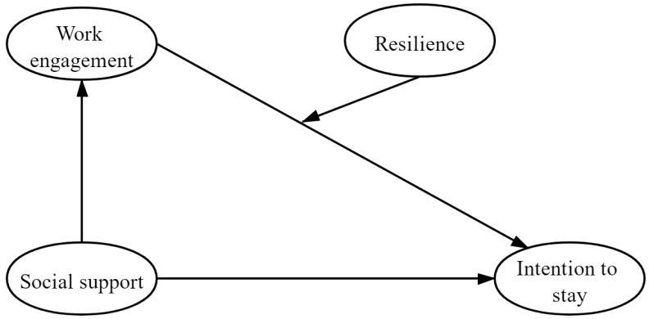
Figure 1. Research model.

Method
Participants
Our participants were 1963 preschool teachers from 18 counties in 5 cities of the Ningxia Hui Autonomous Region, China. These teachers’ demographic details are shown in Table 1. Among these participants, 98.3% (1664) were female and 1.7% (29) were male. There were 1163 teachers (68.7%) who had worked for 5 years or less, 287 teachers (16.9%) who had worked for 6-10 years and 243 teachers (14.4%) who had worked for more than 10 years. Regarding education level, 364 (21.5%) teachers had an educational background equal to or lower than that of a senior secondary school or a vocational school, 952 (56.2%) had a college education, 358 (21.1%) had a bachelor’s degree, and 19 (1.1%) had a master’s degree or above. In terms of organizational characteristics, 479 (28.3%) participants were urban public preschool teachers, 445 (26.3%) were urban private preschool teachers, 292 (17.2%) were county public preschool teachers, 73 (4.3%) were county private preschool teachers, 227 (13.4%) were village public preschool teachers, and 177 (10.5%) were village private preschool teachers. The average age of these teachers was 27.94 (SD = 7.10), and the average age of the children that they taught was 5.59 years (SD = 6.58).
Table 1 Teachers’ Demographic Details
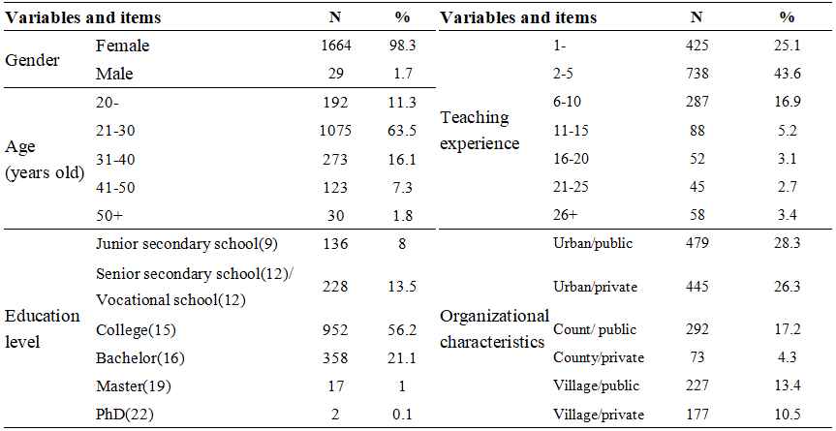
Procedure
We obtained the consent of the teachers’ principals in advance, explained the purpose and the significance of our research to them, and asked the principal to convey the importance of this research to the teachers and to encourage them to cooperate in our investigation. An anonymous network questionnaire was used for the survey. The survey was conducted by a doctoral candidate in preschool education who received professional training. Before the test, the researcher emphasized to the teachers the anonymity and confidentiality of the survey and asked them to fill in the questionnaire after a careful examination. A total of 1855 questionnaires were collected, of which 1693 were valid, for an effective recovery rate of 91.3%.
Measures
Social support scale. To measure teachers' social support, we used the social support scale compiled by Xiao (1994). This scale consists of 10 brief statements and 3 dimensions, including objective support, subjective support, and utilization of support. Examples of these items are as follows: “In the past, when you were in an emergency situation, your sources of comfort and relationships were:” (objective support), “How many close friends do you have who can support and help you” (subjective support), and “How often do you participate in activities organized by groups, such as party and league organizations, religious organizations, labor unions, and student unions” (utilization of support). For questions 1-4 and 8-10, respondents were asked to select only one item for each question. Items 1-4 were to be scored on a scale of 1 to 4. For question 5, participants were to score parts A, B, C and D; each part was to be scored on a scale of 1 to 4 ranging from "None" to "yes". The sum of the scores from parts A, B, C and D represented the total score. For questions 6 and 7, participants were to score 0 to indicate "no sources", if the respondent answered "the following sources", they were to score several sources. The total score was calculated as the sum of the scores of all 10 items. A high score indicated that a respondent received considerable social support. The Cronbach's alpha coefficient of this scale was 0.862.
Work engagement scale. To measure teachers' work engagement, we used the work engagement scale for preschool teachers in China compiled by Wang and Qin (2010). This scale consists of 21 brief statements and 4 dimensions, including work pleasure, work value, work responsibility, and work focus. Examples of these items are as follows: “After work, I want to continue working” (work pleasure), “I am able to play a creative role in preschool education” (work value), “At work, I am strict with myself” (work responsibility), and “I forget everything around me at work” (work focus). The scale uses a 5-point Likert scale, 1 (strongly disagree) - 5 (strongly agree). A high score for this measure indicated that a respondent’s work engagement was high. The Cronbach's alpha coefficient of this scale was 0.934.

Intention to stay scale. To measure teachers' intention to stay, we revised Song Shi’s scale that was used to measure Chinese preschool teachers’ intention to stay. This scale consists of 8 brief statements and 1 dimension. Examples of these items are as follows: “I think my current preschool is suitable for me”, “I like the preschool where I currently work”, “I would like to stay in this preschool”, “I am willing to work hard for the development of this preschool”, “I do not envy my colleagues who have left this preschool”, “I do not want to work in another industry”, “I have not looked for another job”, and “I do not take the initiative to pay attention to the recruitment information of other institutions”. The results of the confirmatory factor analysis are as follows: χ2/df=4.542, GFI=0.994, AGFI=0.976, NFI=0.996, IFI=0.997, TLI=0.991, CFI=0.997, RMSEA=0.046. The scale used a 5-point Likert scale, 1 (strongly disagree) - 5 (strongly agree). A high score for this measure indicated that a respondent had a strong intention to stay. The Cronbach's alpha coefficient of this scale was 0.932.

Resilience scale. To measure teachers' resilience, we used the Chinese teachers' Resilience Scale developed by Li et al. (2014). This scale consists of 13 brief statements and 3 dimensions, including love for and dedication to teaching, work value, self-efficacy, job satisfaction and optimism. Examples of these items are as follows: “I can continue to cherish my love and dedication to students” (love and dedication to teaching), “I have always been confident” (work value), and “I am able to maintain my satisfaction with school teaching” (job satisfaction and optimism). The scale uses a 5-point Likert scale, 1 (strongly disagree) - 5 (strongly agree). A high score for this measure indicated that a respondent had high resilience. The Cronbach's alpha coefficient of this scale was 0.92.

Data Analysis
SPSS 23.0 was used for data analysis, including reliability and validity tests, single factor tests, correlation analyses, and structural equation model tests.

Results
Control and inspection of common method deviation
As the data regarding social support, work engagement, the intention to stay and resilience all are self-reported by the respondents of this study, there may be common method deviation; thus, it is necessary to test for this problem. Using the Harman single factor test to analyze the items of all variables, we discover that the variance of the first factor is 26.807%, which is lower than the critical standard of 40%. This shows that there is no serious common method deviation in the data of study.
Descriptive statistics and correlation analysis
The descriptive statistics and correlation matrix of the variables are shown in Table 2. The intention to stay was positively correlated with social support, work engagement and resilience, but was not correlated with gender.
Table 2 Descriptive statistical analysis and correlation analysis results among the variables
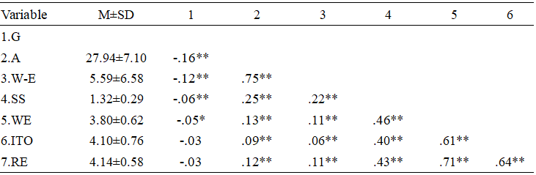
Note. G=gender, A=age, W-E=Work experience, SS=social support, WE=work engagement, ITO=intention to stay, RE=resilience. *p＜0．05，**p＜0.01，***p＜0.001.
Mediating role of work engagement and Moderating role of resilience
First, work engagement and resilience are centralized, and then they are multiplied to form an interaction term. According to the process analysis suggested by Wen Zhonglin et al. (Wen, Zhang, & Hou, 2006), we use the following equations to examine the moderating-mediating effects: (1) Equation 1 is the regression of the dependent variable (intention to stay) on the independent variable (social support) and the regulatory variable (resilience), which requires that the independent variable (social support) has a significant regression coefficient. (2) Equation 2 is the regression of the mediating variable (work engagement) on the independent variable (social support) and the regulatory variable (resilience), which requires that the independent variable (social support) has a significant regression coefficient. (3) Equation 3 is the regression of the dependent variable (intention to stay) on the independent variable (social support), the regulatory variable (resilience) and the mediating variable (work engagement), which requires that the mediating variable (work engagement) has a significant regression coefficient; for each of the equations thus far, the mediating effect is significant. (4) Equation 4 is the regression of the dependent variable (intention to stay) on the independent variable (social support), the regulatory variable (resilience), the mediating variable (work engagement) and the interaction item (resilience × work engagement), which requires that the regression coefficient of the product item (resilience × work engagement) is significant. If all the above four conditions are met, this shows that the regulatory variable plays a mediating role.
Table 3 The relationship between social support and the intention to stay: A moderated mediation model test (n = 1693)

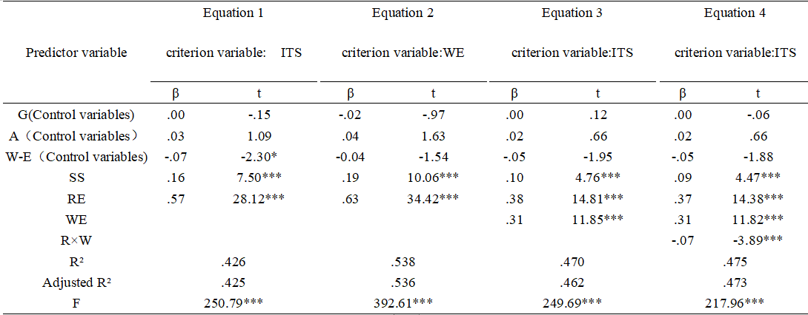
Note. G=gender, A=age, W-E=Work experience, SS=social support, RE=resilience, WE=work engagement, R × W=resilience × work engagement, ITO=intention to stay. *p＜0．05，**p＜0.01，***p＜0.001.
The regression coefficient of social support in equation 1 is significant (β = 0.16, t = 7.50, P < 0.001), indicating that social support has a positive effect on the intention to stay. The regression coefficient of social support in equation 2 is significant (β = 0.19, t = 10.06, P < 0.001), which indicates that social support has a positive effect on work engagement. The regression coefficient of work engagement in equation 3 is significant (β = 0.31, t = 11.85, P < 0.001), indicating that work engagement plays an mediating role in the relationship between social support and intention to stay. Hypothesis 2 is verified, and the amount of the mediating effect (mediating effect / total effect) is 0.27.
To reveal the essence of the interaction between work engagement and resilience more clearly, we conducted a simple slope analysis. Resilience was divided into two groups based on their deviation from the average score; more specifically, the group with scores falling less than one standard deviation from the mean was denoted as the group with low resilience, and the group with scores falling one standard deviation above the mean was denoted as the group with high resilience. Figure 2 demonstrates that when the resilience of preschool teachers is low, the positive effect of work engagement on their intention to stay is significant (β = 0.35, t = 2.80, P < 0.01); when the resilience of preschool teachers is high, there is no significant positive effect of work engagement on their intention to stay (β = 0.42, t = 1.09, P = 0.28). When the value of resilience is one standard deviation under the mean value and one standard deviation above the mean value, the coefficient of the mediating variable is 0.21 and 0.13, respectively; the former is statistically significant, and the latter is not statistically significant.
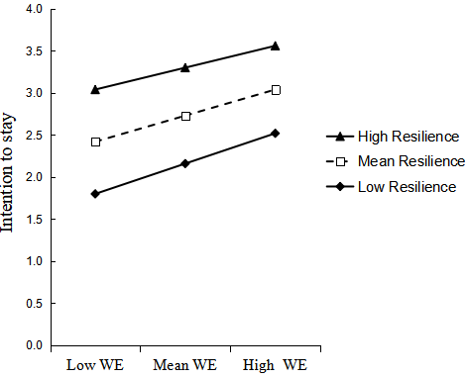
Figure 2. The moderating effect of resilience on the relationship between work engagement and the intention to stay
Note. WE=work engagement.

Discussion

In the past, the discussion of preschool teachers' intention to stay was mostly from the perspective of their resignation. Although resignation is the opposite of the intention to stay, many of the aspects of these concepts are similar to each other; however, there are still differences between them that are worth distinguishing (Cho et al., 2009). This study constructs a moderated model to examine the mediating role of work engagement on the relationship between social support and preschool teachers' intention to stay and whether this role is moderated by resilience. This research is helpful to identify the mechanism underlying the effect of social support on the intention to stay and the conditions under which this effect takes place. The results of this study have theoretical and practical significance for the intervention of preschool teachers' intention to stay.

Theoretical Implications
First, we verified that social support positively influences the intention to stay, thus validating hypothesis 1. This finding is consistent with existing studies (Torquati et al., 2007) and suggests that a high level of social support is a protective factor influencing preschool teachers’ intention to stay. Preschool teachers who feel socially supported are more likely to continue working for their organization than those who do not.

Second, we prove that social support can positively predict work engagement. This shows that hypothesis 2 is validated. This finding is consistent with earlier theoretical and empirical research (Lan & Liang, 2019). It shows that work engagement is the key factor underlying the positive adaptation consequences caused by social support. Individuals with a high level of social support have more trust in their organizations and are more likely to be motivated in their work, while employees without social support have less opportunity to acquire resources and less motivation to develop new skills to achieve work goals (Westman, Hobfoll, Chen, Davidson,& Laski, 2004). This study also shows that work engagement can positively affect the intention to stay (Halbesleben, 2010). Employees with a high level of work engagement are often proud of and encouraged in their work, and they are more likely to regard difficulties that arise in their work as challenges rather than as pressures (Schaufeli et al., 2004). Preschool teachers are under much pressure, their work tasks are difficult and heavy, and their working hours are long (Wang, Cao, & Qin, 2015). A high level of work engagement can not only help preschool teachers adjust their work attitudes and reduce the psychological effort needed to alleviate their work pressures but also play a positive role in improving their job satisfaction and organizational commitment, thus promoting an increase in their intention to stay (Wang & Qin, 2015). Therefore, work engagement plays a "bridge" role between social support and the intention to stay.

Third, we also found that the mediating effect of work engagement on social support and the intention to stay is moderated by resilience. Resilience negatively moderates the relationship between work engagement and the intention to stay in the mediating pathway. Specifically, the inclusion of resilience as a moderating variable explains the boundary moderation that influences the mediating role of work engagement, identifying the circumstances under which work engagement can influence an employee’s intention to stay in a job. Under the moderation of high resilience, there is no significant difference in the influence of work engagement on the intention to stay; that is, resilience is a necessary condition for the intention to stay. However, in cases of low resilience, individuals with a high level of work engagement have stronger intentions to stay than individuals with low work engagement.
These results demonstrate the protective effect of resilience, validate hypothesis 3, and support the results of previous studies (Beltman, Mansfield, & Price, 2011). For preschool teachers, resilience is an important resource that enables teachers to feel self-efficacy and emotional motivation, provides a protective barrier for teachers in stressful situations, and buffers and compensates for the loss of psychological resources due to insufficient work engagement (Li et al., 2014), thus enhancing the intention to stay.
Practical Implications
In this study, we explore the mechanism underlying the effect of social support on preschool teachers’ intention to stay and clarify the protective role of social support on the intention to stay. In contrast to previous studies that focus on the impact of external resources on the intention to stay, we comprehensively explain the positive role of interpersonal and individual resources, which is an important supplement to the previous studies. This contribution has some practical implications for interventions in preschool teachers’ intention to stay. First, the positive relationship between social support and the intention to stay suggests that the level of social support given to preschool teachers by society, preschools, families and other groups or individuals should be increased. For example, this could be accomplished by clarifying the professional status of preschool teachers, improving their working environment, increasing their compensation, and giving them more moral encouragement. We cannot simply ask teachers to work without providing them with adequate work resources and the rewards that they deserve. If preschool teachers face a chronic imbalance between demand and resources, namely, excess demand and insufficient resources, their intention to stay can be significantly reduced. Of course, preschool teachers should also actively seek social support while continuously engaging in self-emotional regulation and working hard at their jobs. In addition, we must create a school environment for preschool teachers that is characterized by respect, trust and encouragement. We should guide and help preschool teachers build good interpersonal relationships with their superiors, their colleagues, young children, other teachers, and parents. Some of these efforts may help teachers gain the courage to cope with stress and challenges, increase their resilience, effectively replenish the depletion of their psychological resources caused by a low level of work engagement, and, finally, avoid a decrease in their intention to stay.
Study Limitations
One limitation of this study is that all the participating teachers came from the Ningxia Autonomous Region, thus our results may not be generalizable to all teachers across the different regions of China. Second, the vast majority of the study population was female, which does not facilitate the application of these findings to male preschool teachers. Third, because preschool teachers are predominantly women, the applicability of these findings to other professions needs to be further explored. A final limitation of this study is that we presented a simple moderated mediation model that only considers the mediating role of work engagement and the moderating role of resilience and does not analyze other variables.
Directions for Future Research
We have four suggestions regarding directions for future research. First, future researchers need to expand the area sampled so that the results can be generalized to other parts of China. Second, researchers need to pay more attention to male preschool teachers and perhaps uncover different mechanisms that influence their intention to stay. Third, the research must involve many different types of occupations to improve the general applicability of the model. Fourth, future research must include diverse influencing factors.

References
Arnup, J., & Bowles, T. (2016). Should I stay or should I go? Resilience as a protective factor for teachers’ intention to leave the teaching profession. Australian Journal of Education, 60(3), 229–244.
doi:10.1177/0004944116667620

Wang,M.,Hong,X.,& Pang,L. (2015). Focus on the development of non-government kindergarten teachers in china:issues, influence factors and policy suggestions. Teacher Education Research, 027(003), 36-42.
doi:10.13445/j.cnki.t.e.r.2015.03.010

Sorensen, L. C., & Ladd, H. F. (2020). The Hidden Costs of Teacher Turnover. AERA Open, 6(1),1-24.
doi:10.1177/2332858420905812

Dalessio, A., Silverman, W. H., & Schuck, J. R. (1986). Paths to Turnover: A Re-analysis and Review of Existing Data on the Mobley, Horner, and Hollingsworth Turnover Model. Human Relations, 39(3), 245–263.
doi:10.1177/001872678603900305

Cho, S. , Johanson, M. M. , & Guchait, P. . (2009). Employees intent to leave: a comparison of determinants of intent to leave versus intent to stay. International Journal of Hospitality Management, 28(3), 374-381.
doi:10.1016/j.ijhm.2008.10.007

Mitchell, T. R. , Holtom, B. C. , Lee, T. W. , Sablynski, C. J. , & Erez, M. . (2001). Why people stay: using job embeddedness to predict voluntary turnover. Academy of Management Journal,44(6), 1102-1121.
doi:10.5465/3069391

Cowden, T. L. , & Cummings, G. G. . (2012). Nursing theory and concept development: a theoretical model of clinical nurses’intentions to stay in their current positions. Journal of Advanced Nursing, 68(7):1646 –1657.
doi:10.1111/j.1365-2648.2011.05927.x

Chen, M. F. , Ho, C. H. , Lin, C. F. , Chung, M. H. , & Li, C. K. . (2015). Organisation-based self-esteem mediates the effects of social support and job satisfaction on intention to stay in nurses. Journal of Nursing Management, 24(1), 88-96.
doi:10.1111/jonm.12276

Gupta,A., & Singh, V. (2018). "Enhancing intention to stay among software professionals". Academia Revista Latinoamericana de Administración,31(3), 569-584.
doi:10.1108/ARLA-11-2017-0319

Fan,X.,& Li,M. (2018). How do we perceive the preschool teacher : from substitute mothers to professionals then to researchers. Teacher Education Research, (4), 92-98.
doi:CNKI:SUN:GDSZ.0.2018-04-014

Sofia, Temam, Nathalie, Billaudeau, Marie-Noël, & Vercambre. (2019). Burnout symptomatology and social support at work independent of the private sphere: a population-based study of french teachers. International Archives of Occupational & Environmental Health.92(6):891-900.
doi:10.1007/s00420-019-01431-6

Bakker, A. B. , & Demerouti, E. (2007). The job demands‐resources model: state of the art. Journal of Managerial Psychology, 22(3), 309-328.
doi:10.1108/02683940710733115

Karatepe, O. M., & Olugbade, O. A. (2016). The effects of work social support and career adaptability on career satisfaction and turnover intentions. Journal of Management & Organization, 23(3), 337–355.
doi:10.1017/jmo.2016.12

Abualrub, R. F. (2010). Work and non-work social support and intent to stay at work among jordanian hospital nurses. International Nursing Review, 57(2), 195-201.
doi:10.1111/j.1466-7657.2009.00768.x

Pomaki, G., DeLongis, A., Frey, D., Short, K., & Woehrle, T. (2010). When the going gets tough: Direct, buffering and indirect effects of social support on turnover intention. Teaching and Teacher Education, 26(6), 1340–1346.
doi:10.1016/j.tate.2010.03.007

Cohen, S., & Wills, T. A. (1985). Stress, social support, and the buffering hypothesis. Psychological Bulletin, 98(2), 310-357.
doi:10.1037/0033-2909.98.2.310

Lo, B. (2014). Stress, burnout and resilience of teachers of students with emotional behavioural challenges. SpringerPlus, 3(1), 1-2.
doi:10.1186/2193-1801-3-S1-O4

Torquati, J. C. , Raikes, H. , & Huddleston-Casas, C. A. . (2007). Teacher education, motivation, compensation, workplace support, and links to quality of center-based child care and teachers’ intention to stay in the early childhood profession. Early Childhood Research Quarterly, 22(2), 261-275.
doi:10.1016/j.ecresq.2007.03.004

Chen,M.F., Ho,C.H., Lin,C.F., Chung, M.H., & Li,C.K. .(2015). Organisation-based self-esteem mediates the effects of social support and job satisfaction on intention to stay in nurses. Journal of Nursing Management, 24(1), 88-96.
doi:10.1111/jonm.12276

Mojsa-Kaja, J. , Golonka, K. , & Marek, T. . (2015). Job burnout and engagement among teachers – worklife areas and personality traits as predictors of relationships with work. International Journal of Occupational Medicine and Environmental Health, 28(1), 102-119.
doi:10.13075/ijomeh.1896.00238

May, D. R. , Gilson, R. L. , & Harter, L. M. . (2011). The psychological conditions of meaningfulness, safety and availability and the engagement of the human spirit at work. Journal of Occupational & Organizational Psychology, 77(1), 11-37.
doi:10.1348/096317904322915892

Danes, S. M., & Rettig, K. D..(1995).Economic adjustment strategies of farm men and women experiencing economic stress. Financial Counseling and Planning,(6):59–74.

Demerouti, E. , Bakker, A. B. , Jonge, J. D. , & Schaufeli, J. W. B. . (2001). Burnout and engagement at work as a function of demands and control. Scandinavian Journal of Work, Environment & Health, 27(4), 279-286.
doi:10.2307/40967145

Othman, N. , & Nasurdin, A. M. . (2013). Social support and work engagement: a study of malaysian nurses. Journal of Nursing Management, 21(8), 1083-1090.
doi:10.1111/j.1365-2834.2012.01448.x

Zeng,L.,He,M.,& Zhao,S.(2018). The Impact of Social Support on Rural Teachers′ Work Engagement From the Double Perspective of Work-Family Balance - A Multiple Mediation Model. Studies of Psychology and Behavio,4,518-524.
doi:10.3969/j.issn.1672-0628.2018.04.013

Bakker, A. B. , & Demerouti, E. . (2008). Towards a model of work engagement. Career Development International, 13(3), 209-223.
doi:10.1108/13620430810870476

Cropanzano, Russell, Wright, Thomas, & A. (2001). When a "happy" worker is really a "productive" worker: a review and further refinement of the happy-productive worker thesis. Consulting Psychology Journal: Practice and Research,53,182-99.
doi:10.1037/1061-4087.53.3.182

Schaufeli, W. B. , & Bakker, A. B. . (2004). Job demands, job resources, and their relationship with burnout and engagement: a multi-sample study. Journal of organizational behavior, 25(3), 293-315.
doi:10.2307/4093692

Irena Burić, & Macuka, I. . (2018). Self-efficacy, emotions and work engagement among teachers: a two wave cross-lagged analysis. Journal of Happiness Studies, 19(7), 1917-1933.
doi:0.1007/s10902-017-9903-9

Kim, W., & Park, J. (2017). Examining Structural Relationships between Work Engagement,Organizational Procedural Justice, Knowledge Sharing, and Innovative Work Behavior for Sustainable Organizations. Sustainability, 9(2), 205.
doi:10.3390/su9020205

Vicente González-Romá, Schaufeli, W. B. , Bakker, A. B. , & Lloret, S. . (2006). Burnout and work engagement: independent factors or opposite poles?. Journal of Vocational Behavior,68(1), 165-174.
doi:10.1016/j.jvb.2005.01.003

Parkes, L. P. , & Langford, P. H. . (2008). Work–life bal ance or work–life alignment? a test of the importance of work-life balance for employee engagement and intention to stayin organisations. Journal of Management & Organization, 14(03), 267-284.
doi:10.1017/S1833367200003278

Hakanen, J. J. , Bakker, A. B. , & Schaufeli, W. B. . (2006). Burnout and work engagement among teachers. Journal of School Psychology, 43(6), 495-513.
doi:10.1016/j.jsp.2005.11.001

Takawira, N., Coetzee, M., & Schreuder, D. (2014). Job embeddedness, work engagement and turnover intention of staff in a higher education institution: An exploratory study. SA Journal of Human Resource Management, 12(1),1- 10.
doi:10.4102/sajhrm.v12i1.524

Noraani, M., Aminah, A., Jegak, U., & Khairuddin, I. (2010). Job characteristics as antecedents of intention to stay and mediating effects of work family facilitation and family satisfaction among single mothers in Malaysia. International Journal of Business and Social Science, 3(1), 59-74.
doi:10.1111/ceo.12009

Gu, Q. , & Day, C. . (2013). Challenges to teacher resilience: conditions count. British Educational Research Journal, 39(1).22-44.
doi:10.1080/01411926.2011.623152

Mansfield, C., Beltman, S., & Price, A. (2014). “I”m coming back again!’ The resilience process of early career teachers. Teachers and Teaching, 20(5),547–567.
doi:10.1080/13540602.2014.937958

Xiao,S.Y.(1994).Theoretical basis and research application of social support rating scale. Journal of Clinical Psychiatry, 1994, 4(2):98-100.
doi:CNKI:SUN:LCJS.0.1994-02-019

Wang,Y., & Qin,J.(2010).Development of the Kindergarten Teachers’Work Engagement Questionnaire.Psychological Development and Education,5,534-542.
doi:10.7666/d.y1237886

Li,Q.,Pei,L., & Wu,D.(2014). Teacher Resilience:Construct and Influential Factors. Journal of Educational Studies,2,72-78.
doi:CNKI:SUN:XKJY.0.2014-02-013

Wen,Z.,Zhang,L., & Hou,J. (2006). Mediated Moderator and Moderated Mediator. Acta Psychologica Sinica, 38(3), 448-452.

Lan,H., & Liang,B.(2019).The relationship between work values and work engagement of rural primary and secondary school teachers: the mediation of social support.Journal of Sichuan Normal University(Social Sciences Edition),4,96-104.
doi:10.13734/j.cnki.1000-5315.2019.04.012

Westman, M. , Hobfoll, S. E. , Chen, S. , Davidson, O. B. , & Laski, S. . (2004). Organizational stress through the lens of conservation of resources (cor) theory. Research in Occupational Stress and Well Being, 4, 167-220.
doi:10.1016/S1479-3555(04)04005-3

Halbesleben J.R.B. (2010) A meta-analysis of work engagement: relationships with burnout, demands, resources, and conse-quences. In Work Engagement: A Handbook of Essential Theory and Research (A.B. Bakker & M.P. Leiter eds),pp. 102–117. Psychology Press, New York, NY.

Wang,P.,Cao,R. & QIN,J.(2015).On Kindergarten Teachers’Career Pressure.Studies in Early Childhood Education,4,58-63.
doi:10.13861/j.cnki.sece.2015.04.011

Wang,Y., & Qin,J.(2015). The Influence of Kindergarten Teachers’ Work Engagement on Their Work Attitude and Mental Health.Studies in Early Childhood Education,2,58-65.
doi:10.13861/j.cnki.sece.2015.02.010

Beltman, S. , Mansfield, C. , & Price, A. . (2011). Thriving not just surviving: a review of research on teacher resilience. Educational Research Review, 6(3), 185-207.
doi:10.1016/j.edurev.2011.09.001

